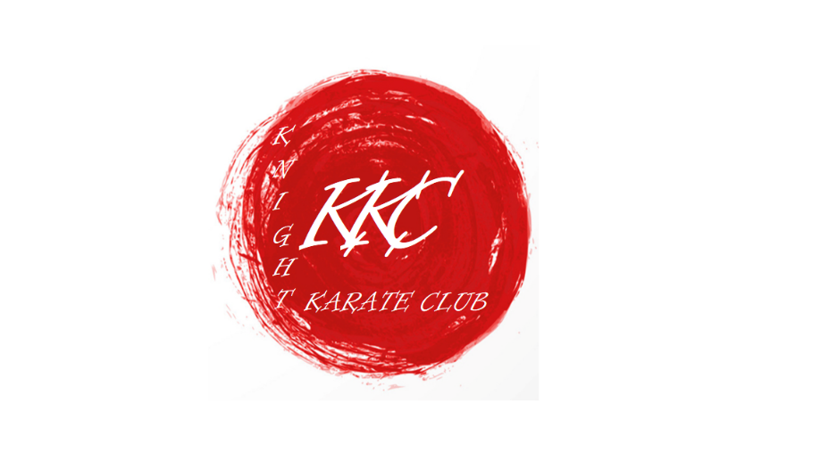

KUGB and KKC Constitution, Structure and Procedures
Constitution
The aims and objectives of the KUGB AND KKC will be to:
- Foster and develop the Art, Sport and practice of KUGB Shotokan Karate in Great Britain
- Unite persons wishing to learn, practice and support KUGB Shotokan Karate
- Provide technical rules and documentation relating to the safety and equity of members and maintenance and development of standards
- Do all such things that are considered necessary to achieve the above aims and objectives including the collection, receipt and administration of funds
Code of Conduct for all KUGB Instructors and Students
- The Art of Karate-Do places great emphasis on the Dojo code which aims to improve the character of its students through the development of respect, sincerity, effort, etiquette and self control through Karate training. The Karate Union of Great Britain uses this code of behaviour so that technical skill, physical fitness and good behaviour become synonymous with Karate-Do.
- Character improvement is developed through the practices that are involved within its structured classes and has an important effect on the practitioners general well being both behaviourally and physically.
- All KUGB members have a duty to behave in ways that maintain and enhance the reputation of their Dojo and the KUGB, instructors have a particular responsibility as they greatly
influence the behaviour of their students.
Instructors must ensure that the following code of behaviour is explained and adhered to by all students in their charge.
Dojo etiquette:
- Always bow respectfully when entering and leaving the dojo.
- Always bow respectfully before and after Kumite practise.
- Junior grades must bow first to their seniors.
- Always respond to advice from an instructor by answering "oss".
- Instructors must be referred to as Sensei.
- Nails must be kept clean and short and jewellery and watches must not be worn. If it is not possible to remove rings or earrings, they should be safely covered.
- It may be requested that shoes are removed on entering the Dojo.
Students must show great respect for the Dojo and make every effort to be on time for classes. If late, they must kneel at the front side of the Dojo and await the Sensei's signal to join the class. When the signal is given, they must bow in the kneeling position and walk around the back of the class to a position appropriate to their grade.

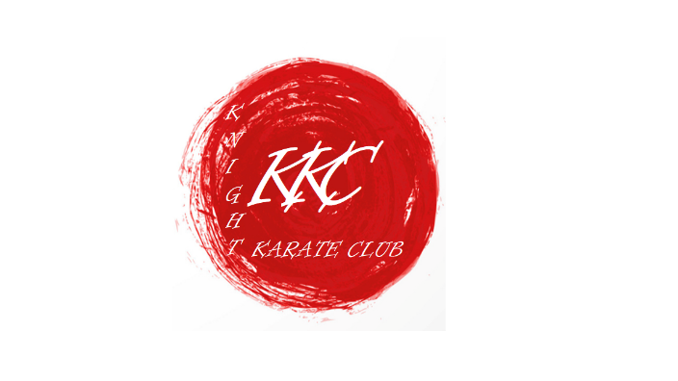

All behaviour must be refined and appropriate and must not offend the etiquette of the Dojo.

Karate Gi and Belt:
- A white Karate Suit ( Gi ) must be worn for training and it is the responsibility of the individual to ensure that their Gi is always clean and in good condition.
- A KUGB or club badge may be embroidered or stitched on to the left breast of the Gi.
- A belt, appropriate to the students grade, must be worn with the Gi at all times.
Training at another Dojo:
- A KUGB licence will insure you to train at any affiliated KUGB Dojo, but permission to do so is needed from the Dojo Instructor, and from your own Instructor.
Competitions:
- For all intents and purposes, the Competition Arena should be treated as the Dojo. Karate competition is seen as the 'glamour' side of Karate, and competitors, especially those who become successful, will become 'role-models' and can have a marked influence on the behaviour of others and therefore they have a special responsibility to exhibit exemplary behaviour with regard to etiquette, sportsmanship, fairness, respect and honour when both winning and losing.
- Referees and Judges must also show exemplary behaviour in the above matters.
- Although the majority of Karateka do not take part in competition, they will use freestyle kumite within the Dojo and also as part of their training for Dan Gradings. It is therefore important that the Instructor teaches a basic understanding of the rules of competition for those students who compete in formal competitions and who need to demonstrate freestyle kumite for gradings. KUGB competition rules are available here.
Outside the Dojo:
- As stated, members have a responsibility to behave in a manner that maintains and enhances the reputation of the KUGB and Karate-Do, both in and outside of the Dojo, and to refrain from any behaviour that is likely to bring Karate or the KUGB into disrepute.
Advertising:
- All advertising by Instructors, Clubs and event organisers must be accurate, ethical and in good taste.

